DEALS TO OAKLAND

Just across the bay from San Francisco, Oakland offers its own fantastic food scene and is a center for the technology industry. From fantastic waterfront views to famous live music venues, there’s plenty to do in “The Town”. Book a trip to Oakland via San Francisco International Airport on Virgin America. Live it up at 35,000 feet with WiFi, on-demand entertainment, and more on every flight.

(MARKET IMAGE HERE)

Find Deals From These Cities

INSERT FARE GRID FROM / TO Version (if available!)

   
Top Things To Do in Oakland

Whether you’re visiting for work or play you won’t run out of things to do in Oakland, CA.

* Some of the Bay Area’s best restaurants are in Oakland, from the high-end Commis to low-key but delicious brunch spots like Aunt Mary’s.
* Looking for a great night out? Check out the live music line up at the historic Fox Theater in downtown Oakland.
* Take an aerial ride over giraffes and lions at the Oakland Zoo. Home to more than 660 native and exotic animals, this zoo offers a great way to enjoy the sunny California climate while learning more about endangered species and conservation efforts.
* Jack London Square is situated along the scenic Oakland/Alameda estuary. It’s a vibrant destination for dining, shopping and community events such as farmer’s markets and live music. Visit for a stroll along the water and stop to enjoy the freshest catch at Jack’s Oyster Bar & Fish House.
* Have a small traveler to entertain? Visit Children’s Fairyland, a wonderful theme park based on famous storybooks.
* Be inspired by the cosmos at Chabot Space & Science Center. Experience the interactive displays, exhibits and Planetarium shows exploring the mysteries of the universe. Meet Nellie, Rachel and Leah, the three largest telescopes on the West Coast that are open to the public.

Travel Tips and Resources

[Oakland Zoohttp://www.oaklandzoo.org/staging/Rides_Area.php](http://www.oaklandzoo.org/staging/Rides_Area.php)

<http://www.oaklandzoo.org/staging/Rides_Area.php>

[Jack London Squarehttp://www.jacklondonsquare.com/](http://www.jacklondonsquare.com/)

<http://www.jacklondonsquare.com/>

[Children’s Fairylandhttp://fairyland.org/](http://fairyland.org/)

<http://fairyland.org/>

[Chabot Space & Science Centerhttp://www.chabotspace.org/about-chabot.htm](http://www.chabotspace.org/about-chabot.htm)

<http://www.chabotspace.org/about-chabot.htm>

[Oakland Restaurantshttp://www.bonappetit.com/restaurants-travel/navigator/article/oakland-navigator](http://www.bonappetit.com/restaurants-travel/navigator/article/oakland-navigator)

<http://www.bonappetit.com/restaurants-travel/navigator/article/oakland-navigator>

[Oakland Shopping Guidehttp://www.streetadvisor.com/oakland-alameda-county-california/questions/best-places-to-shop-in-oakland-ca](http://www.streetadvisor.com/oakland-alameda-county-california/questions/best-places-to-shop-in-oakland-ca)

<http://www.streetadvisor.com/oakland-alameda-county-california/questions/best-places-to-shop-in-oakland-ca>

[Oakland Art Murmurhttp://oaklandartmurmur.org/](http://oaklandartmurmur.org/)

[Oakland Nightlifehttp://www.visitoakland.org/things-to-do/nightlife/](http://www.visitoakland.org/things-to-do/nightlife/)

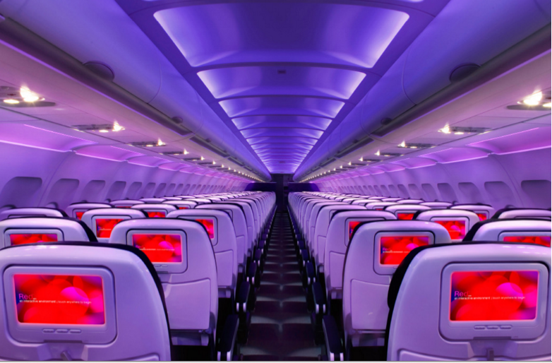

Main Cabin Main Cabin Select First Class

(add links to Cabin Class Pages)

Ready. Set. Fly.

Book your Mood-lit Ride to Oakland.

Thinking about flights to Oakland, CA? When visiting the Bay Area many people fly into San Francisco International and explore all the region has to offer, from Palo Alto to Oakland. Fly to San Francisco with Virgin America and enjoy our ultra-comfortable leather seats, relaxing mood-lit cabins, and the best in-flight entertainment you can find at any altitude. We guarantee you’ll arrive feeling relaxed and ready for all the adventures that await you.

Take a Virtual Tour

Add Terms & Conditions